MEAN AND MEDIAN OF A FILE - LAB REPORT

1) Enter your name, student ID, platform (Mac or PC) and date
Name and Student ID: Jay Gupta, Student ID: 0961979
Class: CIS054 C/C++ Programming
Platform (Mac or PC): PC
Date: 3/30/2020

DESCRIPTION:
In this lab assignment, you are to read a file with an odd number of records, compute the mean and median of the field that has account balances. Repeat the process with a file that has an even number of records. The two files are provided as part of the lab assignment and are named Balances-1.txt and Balances-2.txt. You need to run the program for each file and compute the median value for each file.

NOTE: The code for processing a disk file is very different between the C and C++ languages. There are separate code examples for C and C++. The code samples show how to read a disk file and skip records until you reach the location of the records that will contain the values to be used when computing the median value. You can verify that you have the correct results by opening the files with a spreadsheet program (Microsoft Excel, Apple Numbers or OpenOffice Calc), select the column with the balances and compute the median value with one of the statistical functions.

Sample code is given at the end of this lab assignment. Insert code in the while loop with code to compute the total of all balances. After the while loop completes, display the total of all balances.

To open a file, you must specify the full pathname and filename. This is called the fully-qualified filename. For example, when in C or C++, to open a file named Balances.txt that is located on the desktop, the fully-qualified filename on my system would be:
/Users/Dan/Desktop/Balances.txt
For this lab, you will need to process the Balances-1.txt and Balances-2.txt.
Run the program twice, once for each file.

The pathname consists of your HOME directory and /Desktop which is a folder on the operating system that refers to the desktop. For example, my HOME directory is located at /Users/Dan
My desktop is located at /Users/Dan/Desktop This is true for either a Mac or PC.

Mac - To display the location of the HOME directory on a Mac running OS/X
1) Go to Launchpad and launch Terminal
2) At the Terminal prompt, type echo $HOME
3) Use this information followed by /Desktop/Balances.txt as the fully-qualified filename. Don’t forget the / at the beginning of the path and filename.

Windows - To display the location of the HOME directory on a PC running Windows
1) Click the START button on Windows located at the lower-left side of the screen
2) When the box pops up at the bottom that says, "Search programs and files", type cmd and press [Enter]
3) At the command prompt, type: echo %UserProfile%
4) Use this information followed by /Desktop/Balances.txt as the fully-qualified filename. Don’t forget the / at the beginning of the path and filename.

SPECIAL NOTE FOR PROGRAMMERS ON WINDOWS SYSTEMS
Windows uses the backslash character \ to separate parts of the pathname and filename. The C programming language was created to create the Unix operating system which uses the forward slash character / to separate the parts of the pathname and filename.

C and C++ use the backslash \ in character strings as an escape to give a new meaning to the next character. For example, \n is new line, \b is backspace, \t is tab, etc. It is necessary to type two backslashes \\ inside of a quoted string to get one backslash \ in memory. For example, to get this:
\Users\Dan\Desktop
The quoted string in a C or C++ program must be written as:
"\\Users\\Dan\\Desktop"

Since web servers were originally developed on Unix systems, the forward slash / is used in web addresses. To make Windows compatible with the rest of the world, Windows now accepts forward slashes / as well as backslashes \ as part of a filename and they can be used interchangeably. In C or C++, you can now use
"/Users/Dan/Desktop"
as well as
"\\Users\\Dan\\Desktop"
to get the same result when referring to a file.

LAB REPORT:
2) Determine the Inputs, Processing and Outputs before creating the program.
INPUTS | PROCESSING | OUTPUTS
- Name of the File | - Take in the name of the file, and open it, using the full directory. Display to the user if opening was successful, and if it wasn’t, display an error message and exit.  - Count the number of records in the file, whilst adding each account’s balance to the total. This is done until the end of the file.  - Close the file, and display the number of records, total, and mean. The mean is the total divided by the number of records.  - Find the median. If the number of records is odd, the recordsToSkip is numOfRecords / 2. Else, it’s (numOfRecords / 2) – 1.  - Open the file, and each pass through, decrement the recordsToSkip while it’s greater than 0. When recordsToSkip is 0, this is the record we want for odd number of records, and the first when even number of records (find the second record for even).  - When it is even, the median is the average of the middle two records. Display the median.  - Close the file and return 0. | - Number of Records  - Total  - Mean  - Median

3) Fill in the EXPECTED & ACTUAL RESULTS.
TEST DATA VALUES | EXPECTED RESULT  Use a spreadsheet program to determine the expected median values | ACTUAL RESULT  Fill in the output displayed  by the program
Balances-1.txt  Mean  Median  Balances-2.txt  Mean  Median | Balances-1.txt:  Mean: 1136.13  Median: 1151.03  Balances-2.txt:  Mean: 1132.46  Median: 1150.22 | Balances-1.txt:  Mean: 1136.13  Median: 1151.03  Balances-2.txt:  Mean: 1132.46  Median: 1150.22

DISCUSSION:
4) Complete the DISCUSSION section. It does not need to be long, but it needs to be complete.
4a) What did you do to develop the program? ("Followed the Directions" is not a complete description)

To develop the program, I first figured out what the inputs and outputs would be. Seeing as the project description, and even the name of the file is MeanAndMedian…I figured that we will be using values such as total and middle to find these values. Next, I looked at the project slideshow, to get a better idea of how I would program it. I finished the processing section, and then worked on the project. I soon ran into a very frustrating error (which I will of course elaborate on in the next section), and that took me a while to work through. After doing that, I worked on displaying the values, and finding the median, much later. At times, in order to get a better sense of the project, I wrote simple data lists on paper, and constructed algorithms based on those, which I could use in the actual project.

4b) What problems did you have and how did you overcome the problems?

A major issue I had was with the decimal places. At first, when I was printing the total of the numbers, I was getting a value that was an integer. Of course, I looked at Excel’s total, and it was containing decimal values. I tried ‘cout’(ing) the total & balance at various parts of the while loop, and figured out that the decimal was being lost throughout the loop. This, as I later realized, was because I hadn’t used the Paycheck lab’s fixed and setprecision methods. As a result, the compiler was automatically rounding the values, or making them only 1 decimal place. Once I implemented these methods, everything was fine.

PROGRAM OUTPUT:
5) Display a total of four screenshots. Show two screen shots for each data file. Show a screenshot displaying
5a) result of using a spreadsheet program to calculate the median and mean, and
5b) screenshots showing the execution of the program for the two data files.

Balances-1.txt:

a)
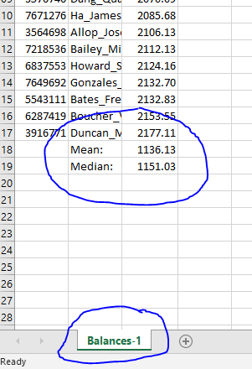

b)
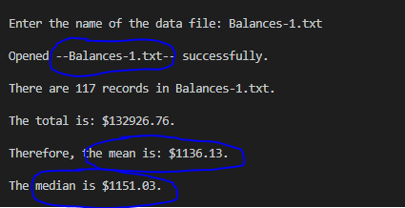

Balances-2.txt:

a)
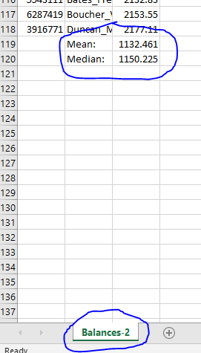

b)
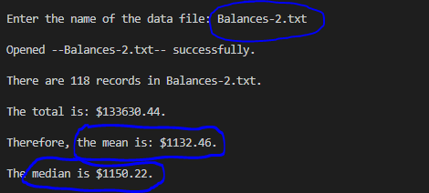

PROGRAM LISTING:
6) Copy and paste the code that YOU typed to make the program work. Your program should include a comment block at the top that shows the name of the program, date, version and your name.

/**
* MeanAndMedianOfDataFile-V1.0
* Program Name: MeanAndMedianOfDataFile.cpp
* Name: Jay Gupta
* Student ID: 0961979
* Date: 3/30/2020
* Inputs: Name of the File
* Outputs: Number of Records, Total, Mean, Median
*/

#include <iostream> // cin and cout
#include <fstream> // (input file stream)
#include <iomanip>
using namespace std;

int main() {
// variables to control disk files
ifstream inFile;
string startingRoot = "C:\\Users\\jaygu\\School\\SJCC\\C++\\Assignments\\Module 9\\9.2_Mean_&_Median_of_a_Disk_File\\Balance_Files\\";
string textFile;

// inFile variables
int acctNo = 0;
string name = "";
double acctBal = 0.0;

int numOfRecords = 0; // to count number of records

// mean, median, and mode variables
double total = 0.0;
double mean = 0.0;
int recordsToSkip = 0;
double median = 0.0;

cout << endl << "Enter the name of the data file: ";
cin >> textFile;

string fullDirectory = startingRoot + textFile;

inFile.open(fullDirectory);
if (!inFile) {
cerr << endl << "Unable to open --" << textFile << "--, first pass." << endl << endl;
exit(1);
} else {
cerr << endl << "Opened --" << textFile << "-- successfully." << endl << endl;
}

cout << fixed;
cout << setprecision(2);

// Part 1: Count the Number of Records in the File
inFile >> acctNo >> name >> acctBal;
while (!inFile.eof()) {
if (name[0] != 0) { // ignore empty records
total += acctBal;
numOfRecords++;
}
name[0] = 0; // initialize to 0 to test for empty records
inFile >> acctNo >> name >> acctBal;
}
inFile.close();

cout << "There are " << numOfRecords << " records in " << textFile << "." << endl << endl;

cout << "The total is: $" << total << "." << endl << endl;

mean = total / numOfRecords;
cout << "Therefore, the mean is: $" << mean << "." << endl;

// Part 2: Determine the number of records to skip
bool isOdd = numOfRecords % 2 == 1;

if (isOdd) {
// odd number of records
recordsToSkip = numOfRecords / 2;
} else {
// even number of records
recordsToSkip = (numOfRecords / 2) - 1;
}

// Part 3: Determine the median, given the recordsToSkip
inFile.open(fullDirectory);
if (!inFile) {
cerr << endl << "Unable to open --" << textFile << "--, first pass" << endl << endl;
exit(1);
}

while (recordsToSkip > 0) {
// if recordsToSkip is 0, stop
inFile >> acctNo >> name >> acctBal;
recordsToSkip--;
}

// this is the record we want
inFile >> acctNo >> name >> acctBal;

if (isOdd) {
// if it's odd, this is all we need
median = acctBal;
} else {
// if even, we have to get the next record too
double firstNum = acctBal;
inFile >> acctNo >> name >> acctBal;
double secondNum = acctBal;

median = (firstNum + secondNum) / 2;
}

cout << endl << "The median is $" << median << "." << endl << endl;
inFile.close();

return 0;
}

